Access Group Meeting
Date: 9th November 2010
Venue: ACE North, Manchester
Time:10.00-3.00
Present: Marcus Friday (Barnsley AT), Anna-Stina Ponsford (Meru), Lisa Price (ACT, Birmingham), Meike Curry (Kings, London), Sarah Wilcock (ACE North), Lisa Farrand (ACE North), Will Wade (ACE Oxford), Dr David Porter (Dynamic Controls), Andy Walker (ACE North Trustee)
- Numbers and location
Clear that individuals are finding it difficult travelling up north for these meetings. Where do we go? Oxford is difficult for car parking, and ACE Oxford far away from train station. Should we approach AT companies for venues? Suggestion of Dynamics (Kidderminster), Smartbox (Malvern) (who can provide training at the train station!), Whizz-Kidz (Victoria, London).
Action: Will to investigate location for November 2011 meeting.
- Data collection.
Will has had a pretty low turnout (5 returns plus two on the day). Data is patchy. Some discussion about lack ofclarity about column descriptors. What do we do? Agreed that perhaps the data collection was never going to give the right data due to everybody’s service being different in who, why and how they see clients. The presentation by Jane Bache (Putney) on breaking down the time taken to provide a client with an end solution is perhaps the best and richest solution. A set of case studies collated with the time and resources required to provide a client with a successful access/eAT/communication method would provide the community a wealth of information to inform service managers etc.
Action: For services to try and break down costs, time and resources required for 1, 2 or more clients. Use it for your own CPD and for the greater good by sharing it centrally with the access group. Down the road, if we have enough case studies we should collate and write it up for publication.
- Presentation by Marcus on Accessible language assessment.
Marcus (Barnsley AT Service) presented work put together by himself and colleagues which has the aim to help assess language in those whom have difficulty in accessing normal standardised tests. The assessment has been developed in the Grid and the results are recorded using the data logging function in the Grid with a customised database developed by Marcus. Marcus noted that they are having some difficulty with ethical approval but not sure why. Marcus not entirely sure whether this is a standardised tool (or based on a standardised tool) or whether this is a tool looking to be standardised. Looks like an interesting tool. Will mentioned his work on developing already standardized cognitive assessments on eyegaze/touchscreen devices.
- Show and Tell! (Geek Factor!)
Marcus presented his disambiguation tool using an external usb number pad and AutoHotKey to do step-through (manual) T9. (sidenote: T9 stands for “type on 9” or type on 9 keys. It’s used throughout the mobile industry (interestingly the licence is now owned by Nuance) – the older way (and often preferred for a large number of users) is where you would have to press the abc key three times to get to C. (sidenote 2: T9 has an interesting history. It was first developed actually on a eyetracking system – take a read of this for more info: http://www.validconcept.com/articles-t9.html). Marcus has developed the system to work with Penfriend to give auditory support of the letters (and words) being pressed.
Will showed other keyboards available: Tapir (from the Inference group: http://www.inference.phy.cam.ac.uk/tapir/ ) and the new Grid 2 word prediction/disambiguation demos. Note though the Grid 2 disambiguation system does not work in computer /application control mode. Also Inscribe (http://www.iliumsoft.com/site/fp/inscribe.php) as a free keyboard that can be designed for touchscreen uses and lastly Dynamic Keyboard from CanAssist (http://www.canassist.ca/EN/main/programs/free-downloads/dynamic-keyboard.html?sredir=1). Other applications to note on a similar vein are JayBee which is work a look at (http://www.jaybee.org.uk/) - of which a demo was shown.
Other demonstrations were provided by Will/ACE North of the Enpathia system (http://smartboxat.com/enpathia.html ) and the W Pen from ability world (http://www.ability-world.com/ ). Sarah W stepped up to the geek factor by showing us OneSwitch Mouse from Claro (http://www.oskaworld.com/category/one-switch-mouse-for-pc.php).
Will also demoed Dragon dicate on the iPad and a few other apps including the mobile air mouse range of apps.
- Discussion around providing mobility practice for individuals
WW noted that Scope used to provide mobility platforms. Something now exists in a similar form sold by Quest88 – the Akka (http://www.quest88.com/children's-therapy-products/therapy--gym-equipment/akka-mobility-platform.aspx). An alternative is the Smart chair is also available from Smile Rehab.
- MERU Case studies
Anna-Stina Ponsford talked through her presentation on interesting cases at MERU on a number of cases. Chin switches on LOC-LINE mounting was shown to the team.
- iPortal
Andy (trustee of ACE North) with the help of David from Dynamics demonstrated the iPortal system. The iPortal is an app for the iOS (iPod Touch, iPhone, iPad) that links wirelessly with the Bluetooth module available on a Dynamics equipped chair (requires DX REM 550 controller). Currently the software shows diagnostic information on the chair (e.g. seat programmes, error logs, speed indicator etc.) however in a new version of the software individuals will be able to control the entire iOS device with their wheelchair joystick. The most recent software is required on the iOS device (iOS 4.x – soon to be released on the iPad). Andy felt the system was great and gave him access to something that usually is practically impossible. You can hear some of Andys comments and see a rough demonstration (apologies on the quality!) at http://www.vimeo.com/16697259 and http://www.vimeo.com/16698417
- Andys Xbox controller
Andy showed us his Xbox controller. Built by QuadControl.com it retails for $260. Quite nifty in that it has a mixture of rocker and sip/puff switches. http://quadcontrol.com/joysticks/xbox-360-controller Note also that GimpGear also sell a range of adapted game controllers: http://www.broadenedhorizons.com/
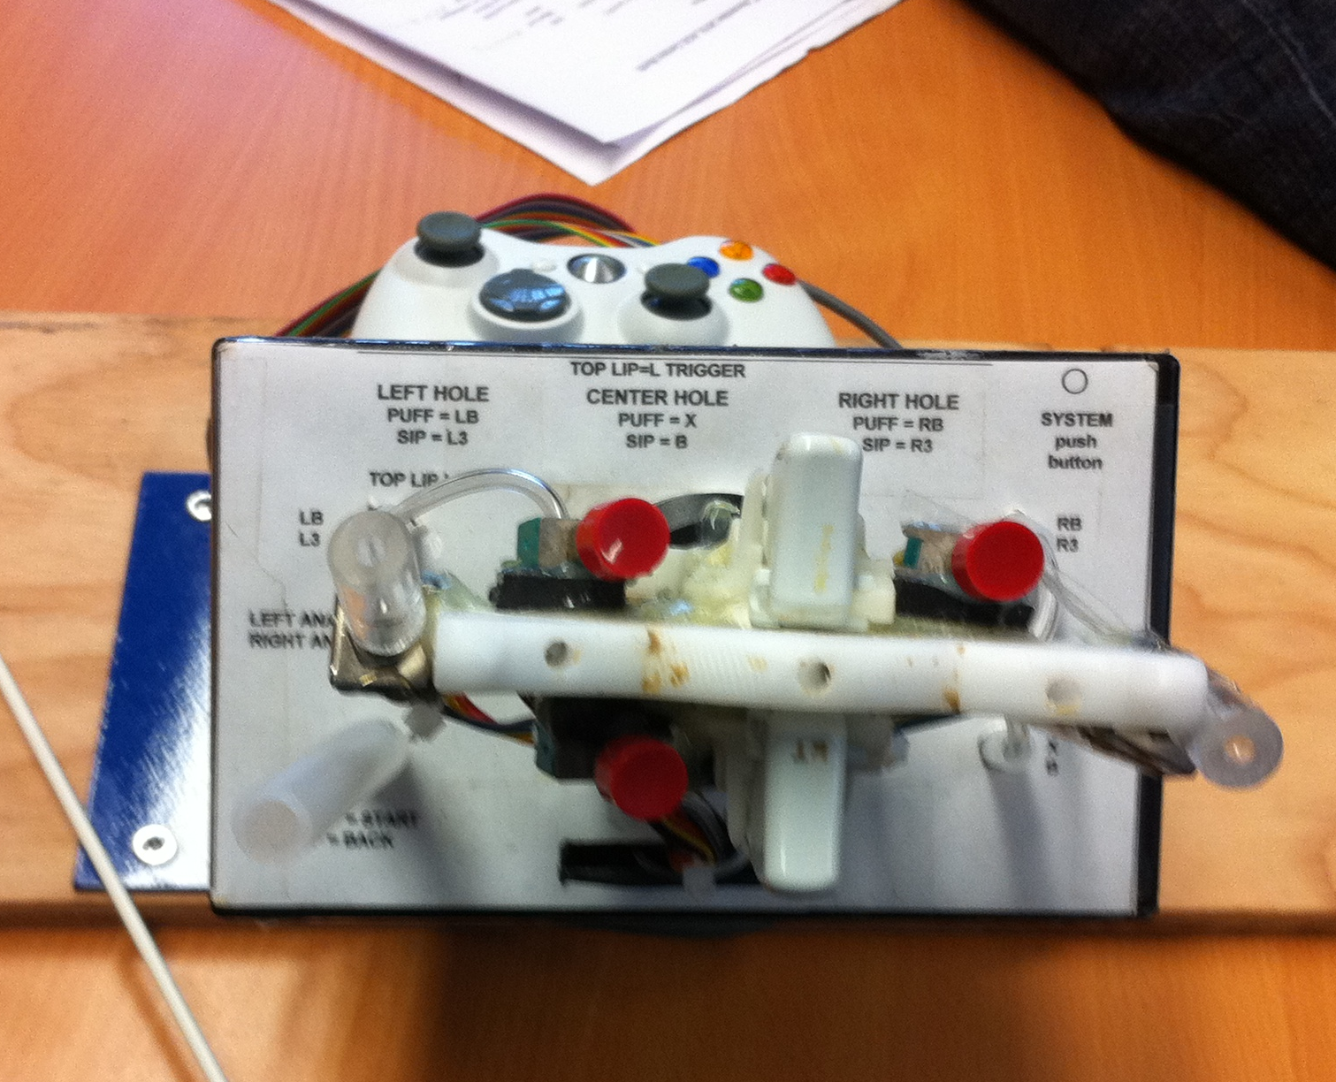
- Lisa Price (ACT) briefly talked through the poster presented by her team at COT conference on developing a toolkit for OTs needing basic access/AT solutions (e.g. software, hardware solutions to access a computer)
- Future Dates set.
Next meeting: 18th May 2011, Wolfson Centre, London.
Meeting after that: 10th November, Venue to be confirmed, ? Kiddeminster @ Dynamics

